**Lab 81**

***Re-write this program (and save it as LastFirst_lab81a.cpp ) so that it searches an array of integers rather than characters. Search the integer array nums[8] =***

***3 6 -19 5 5 0 -2 99***

***for several different integers. Make sure you try integers that are in the array and others that are not.***

I modified the program accordingly and when I search for integers that are in the array the program successfully locates the position. When I search for an integer that is not in the array the program gives it the 9th position.

***What happens if you search for 5?***

It displays: "The integer 5 is in the position 4 of the list"

***Take a screen shot of the output. Save it with your comments in a filename LastFirst_lab81.doc (e.g. DoeJoe_lab81.doc)***

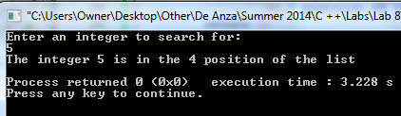

***Re-write the program (and save it as LastFirst_lab81b.cpp ) so that the user can continue to input values that will be searched for, until a sentinel value is entered to end the program. Should a pre or post test loop be used? Take a screen shot of the output. Insert it with your comments in LastFirst_lab81.doc.***

Well that depends, because there are ways to make either a pre test or post test loop work on this program. If you want the user to enter at least one input value, then use a posttest loop. For this reason I used the do while loop. Here's the output of the program with the Sentinel:

